Experiment – 7

Demonstrate virtualization by Installing Type-2 Hypervisor in your device, create and configure VM image with a Host Operating system (Either Windows/Linux), using VMware workstation.
AIM:
To demonstrate virtualization by installing a Type-2 Hypervisor and creating a virtual machine using VMware Workstation.
SOFTWARE REQUIRED:
VMware Workstation 17, Ubuntu ISO, Host OS: Windows
PROCEDURE:
1.Launch VMware Workstation 17 from the Start menu to open the virtualization platform on the host operating system.
2.Confirm that VMware Workstation functions as a Type-2 Hypervisor, meaning it operates on top of the existing host OS rather than directly on hardware.
3.Begin creating a new virtual environment by selecting the option to create a new virtual machine and choose the “Typical (recommended)” configuration to simplify the setup process.
4.Select the operating system installer by choosing the option to use an installer disc image file (ISO), then browse and select the Ubuntu ISO file to proceed with installation.
5.Specify the guest operating system details by selecting Linux as the operating system type and Ubuntu as the version to ensure proper compatibility and configuration.
6.Provide a suitable name for the virtual machine, such as “Virtual Machine Ex-12,” and choose an appropriate storage location on the host system before proceeding.
7.Complete the setup by clicking Finish, after which the virtual machine initializes and the Ubuntu operating system installation begins automatically.

IMPLEMENTATION:



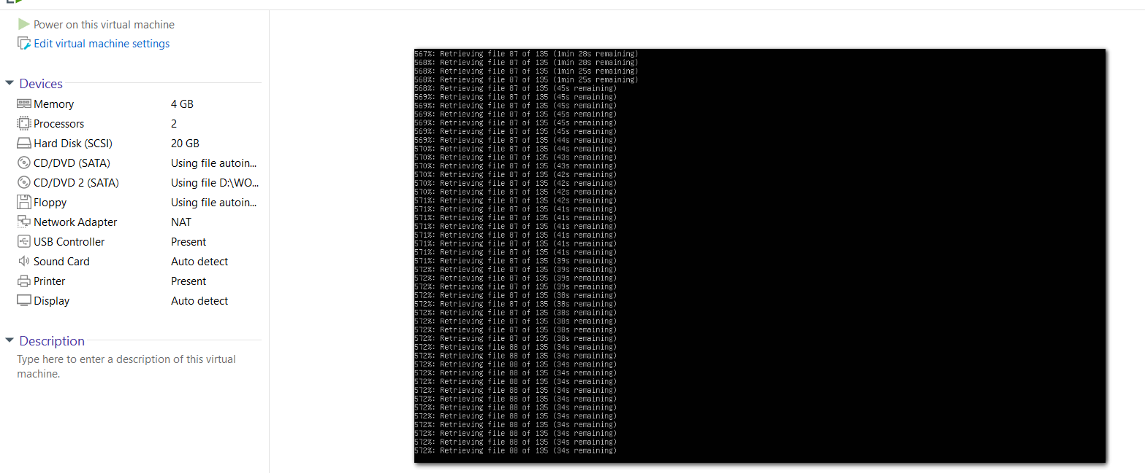
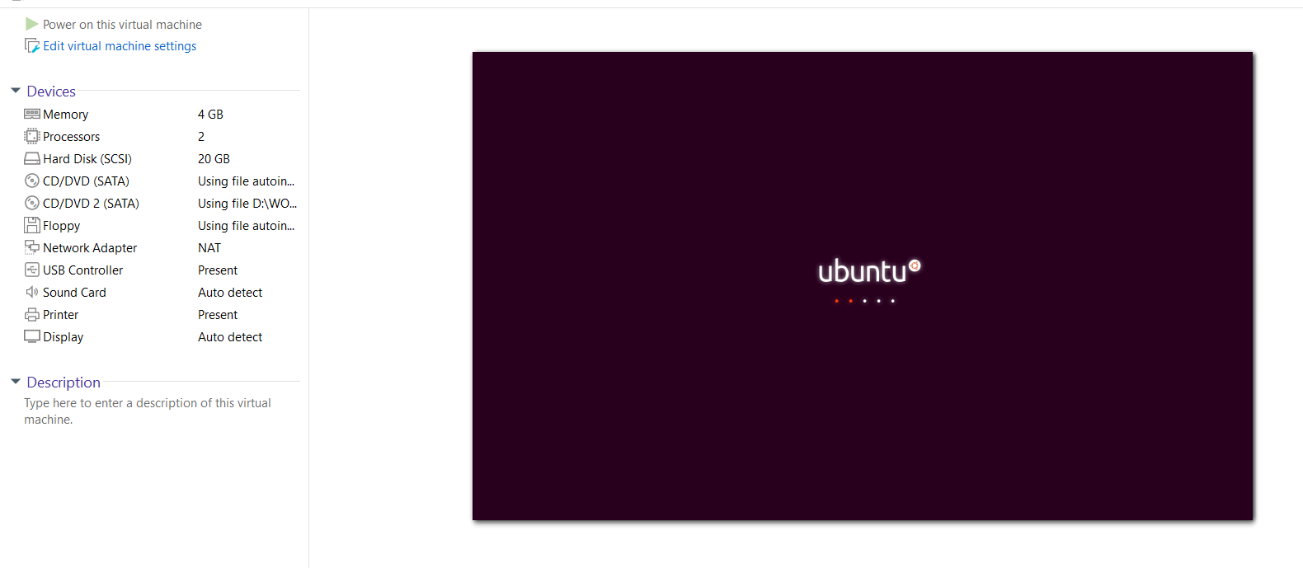

RESULT:
Virtualization is successfully demonstrated using VMware Workstation Type-2 Hypervisor.

